

Department of Electrical & Computer Engineering

Airborne Sampling/Sensing of Distal Volcanic Ash

Project Group Meeting #15

Agenda

Date: Friday July 22nd 2016

Time: 3pm

Venue: VH 457

Chair: Parth Thakur

Secretary: Jake Campbell

1. Apologies

Ryan Taylor

2. Minutes

(Attached)

3. Matters arising

* Size of ash for sample size. Is 75 micron small enough
* Arrival of Modem and telemetry cable

4. Correspondence

All CC’d in all correspondence

5. Progress Reports:

* Mike – Telemetry
* Jamie – Sensor testing
* Jake – Sensor housing
* Parth –Electrostatic sensor

6. Other business:

Minutes from last meeting below:





Department of Electrical & Computer Engineering

Airborne Sampling/Sensing of Distal Volcanic Ash

Project Group Meeting #14

Minutes

**Minutes of the weekly meeting 15 July 2016**

**Present:**

Maan Alkaisi, Adrian Weller, Jamie Van de Laar, Jake Campbell, Parth Thakur, Ryan Taylor, Mike Shanaher

**1. Apologies:**

* NIL

**2. Minutes from last meeting**

* (look at Minutes, July 8 2016)

**3. Matters arising**

* RFD900+ modem bundle
  + Worth getting
  + Range might not be the one stated on the brochure.
  + Take design and power into consideration.
  + Bandwidth issue in NZ. Check if the bandwidth can be adjusted.
  + Be vary of the components placement as it can induce noise.
* Plane Interior (Fig 1.)
  + Ask NIWA if they are happy for the team to change the plane interior
  + Inner will be modularised so changes can be made easily.
  + Center of gravity has to be carefully monitored.
* Wind Tunnel (Fig 2.)
  + DTA can send down a controller to help with the running of the fan.
  + Could use other battery types.
  + Connect the fans independently.

**4. Correspondence**

* NIL

**5. Progress Reports:**

* Jamie Van de Laar
  1. Interfacing Raspberry pi & OPC sensor
  2. Done python scripting.
  3. Done manual connection between the two.
  4. Needs to create a automatic data transfer system through I2C.
  5. Test the whole system in the test chamber with the bulk ash provided
* Jake Campbell
  1. Looked at modularising each sensor.
     1. This is so any necessary changes can be easily made to the plane.
  2. OPC sensor has to be parallel to wind flow
     1. Sensor needs to be vertically mounted.
     2. A hose needs to be connected from the bottom of the plane to the OPC for wind flow.
* Mike Shanaher
  1. See file “Hardware Layout”.
  2. Blue- Standard hardware.
  3. Grey- Motor, RC controller.
  4. Green- Modules added to the system.
  5. Have an SD card to store data in case radio is not operational.
  6. Could log sensor data separately into Raspberry Pi.
* Ryan Taylor
  1. Made tunnel section.
  2. Buy Perspex to add to the wind tunnel.
  3. Look into the insertion of ash into the wind tunnel. It is recommended that ash be put after the honeycomb mesh.
  4. Measure air speed while conduction tests.

6. **Other business:**

**Meeting ACTION LIST**

|  |  |  |
| --- | --- | --- |
| **ACTION** | **ASSIGNED TO** | **DUE DATE** |
|  |  |  |
|  |  |  |
|  |  |  |

**Next meeting date: Friday 22 July 1030hrs**



Figure 1. Plane interior

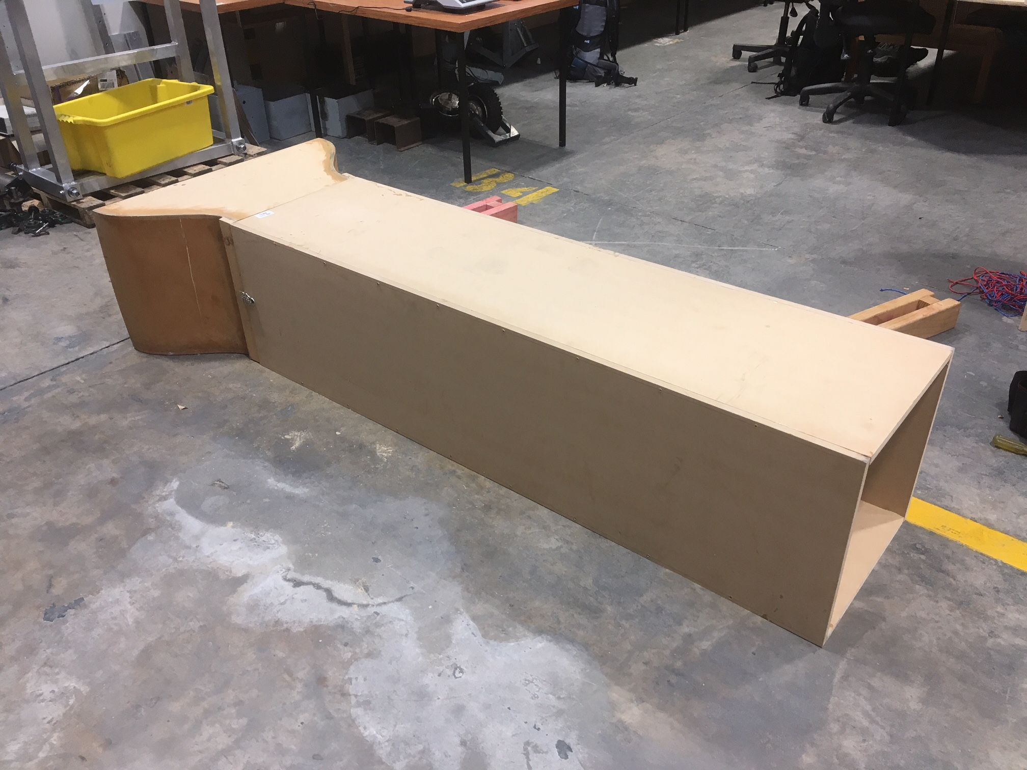

Figure 2. Wind Tunnel